

Columbus City Schools

COMPREHENSIVE SCHOOL SOCIAL WORK PLAN

The Link between Home, School and Community

Focusing on the Whole Child

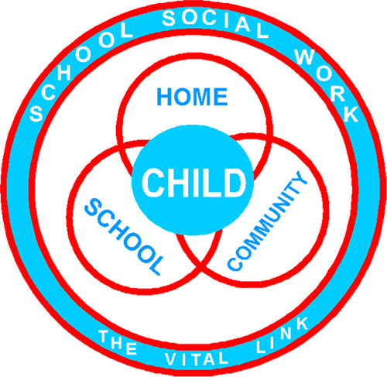

Office of Social Emotional & Student Support Services

2019-2020 Academic Year

Superintendent: Dr. Talisa Dixon

TABLE OF CONTENTS

SCHOOL SOCIAL WORKERS & THE CCS COMMON INSTRUCTIONAL FRAMEWORK 3

PHILOSOPHY OF SCHOOL SOCIAL WORK 4

GUIDING PRINCIPLES OF SCHOOL SOCIAL WORKERS 4

EDUCATION AND LICENSES 5

WHO ARE COLUMBUS CITY SCHOOL SOCIAL WORKERS? 5

MISSION & VISION STATEMENTS 7

NATIONAL SCHOOL SOCIAL WORK STANDARDS 8

CODE OF ETHICS 9

SCOPE OF PRACTICE OVERVIEW 10

SCHOOL SOCIAL WORK MENU OF SERVICES 11

COLUMBUS CITY SCHOOLS BOARD POLICIES 12

MEASUREMENTS OF SERVICE 14

SUPERVISION 14

NEW HIRE MENTOR 17

SCHOOL SOCIAL WORK IN THE MTSS FRAMEWORK 18

Tired Responsive Services provided by School Social Workers 20

Tiered Direct Services provided by School Social Workers in CCS 21

Tiered Indirect Services provided by School Social Workers in CCS 22

POSITIVE BEHAVIOR INTERVENTION AND SUPPORTS (PBIS) 23

TRAUMA INFORMED PRACTICES 24

RESTORATIVE PRACTICES 25

HOUSE BILL 318 26

HOUSE BILL 410 26

ROLE OF THE SCHOOL SOCIAL WORKER AS COURT LIAISON: 27

ROLE OF THE SCHOOL SOCIAL WORKER AS FOSTER CARE LIAISON 28

ccs student support services 31

BIBLIOGRAPHY 32

APPENDIX 33

# SCHOOL SOCIAL WORKERS & THE CCS COMMON INSTRUCTIONAL FRAMEWORK

|  |
| --- |
| **SCHOOL** |
| Reduce risk factors:  Drop-out Prevention & Re-Entry  Restorative/Trauma Frameworks Re-affirm-Repair-Re-build  Suicide Prevention  Social-emotional guided lessons  Individual-Small Group-Class Supports  Staff professional development  Staff consultation  Truancy |
| **HOME** |
| Family Support:  Promote & strenghten home-school relationships  Empower families about educational rights  Link w/community resources |
| **COMMUNITY** |
| Liaison and linkage coordinator:  Basic Needs & Mental Health  Partner w/state & local agencies  Community Outreach and Engagement |

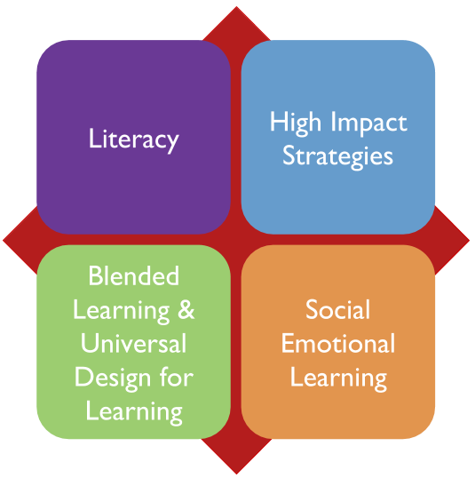

**Student Success**

This figure provides an example of School Social Worker’s alignment to the CCS Common Instructional Framework. It illustrates four of the eight effective instructional strategies identified by John Hattie and Robert Marzano. These strategies are embedded within the services provided by school social workers.

Retrieved from: [8 Strategies Robert Marzano and John Hattie Agree Upon, S. Killian](https://www.cnyric.org/tfiles/folder1306/8%20Strategies%20Robert%20Marzano%20amp%20John%20Hattie%20Agree%20On.pdf)

# PHILOSOPHY OF SCHOOL SOCIAL WORK

Social work practice is the belief in the dignity and worth of all people as they realize their potential to become productive, contributing members of society. School Social Workers are committed to nonjudgmental acceptance of the student and family, shared decision making, equitable education and empowering students to take responsibility for their academic success. School Social Workers function within a culturally responsive framework and have a commitment to enhancing students’ abilities to become life-long learners as they strive to reach their full potential.

# **GUIDING PRINCIPLES** OF SCHOOL SOCIAL WORKERS

(As described in the NASW Standards for School Social Workers)

“For over a hundred years, School Social Workers have been providing a critical link between school, home, and community. The school social work profession has consistently focused on coordinating the efforts of schools, families, and communities toward helping students improve their academic achievement and social, emotional, and behavioral competence by using its unique perspective of viewing the person in his or her environment. School Social Workers seek to ensure equitable education opportunities; ensure that students are mentally, physically, and emotionally present in the classroom; and promote respect and dignity for all students.” School social work is a complex and specialized field of practice that is affected by changes in education policy, research, and practice models that continue to evolve.



# **EDUCATION AND LICENSES**

Columbus City School Social Workers are trained mental health professionals who hold dual licenses. Each Columbus City School Social Worker has a Master’s Degree in Social Work and is licensed by the Ohio Counselor, Social Work and Marriage & Family Therapist Board. As a result, each CCS School Social Worker has one of the following credentials, Licensed Social Worker (LSW), Licensed Independent Social Worker (LISW) or Licensed Independent Social Worker, Supervisor (LISW-S). CCS School Social Workers also hold a Professional License through The Ohio Department of Education honoring their School Social Work specialization. As part of maintaining their Social Work and Ohio Department of Education Licenses, Columbus City School Social Workers receive ongoing training and education to ensure that students, families and school staff receive the highest level of professional services. In fact, state licensing requires social workers to obtain thirty clock hours of continuing education, every two years, with a minimum of three hours specifically covering professional ethics.

# WHO ARE COLUMBUS CITY SCHOOL SOCIAL WORKERS?

As members of the direct educational team, School Social Workers are the link between home, school and the community for all students and families. School Social Workers’ training includes specialized preparation in cultural diversity, systems theory, social justice, risk assessment and intervention, consultation and collaboration, and clinical intervention strategies to address the mental health needs of students and families. School Social Workers work with teachers, administrators, parents and other educators to provide coordinated intervention and consultation designed to keep students on the path to graduation and help families access the supports needed to promote student’s academic and social success. School Social Workers also play an integral role in promoting a positive and safe school climate for all students and staff.

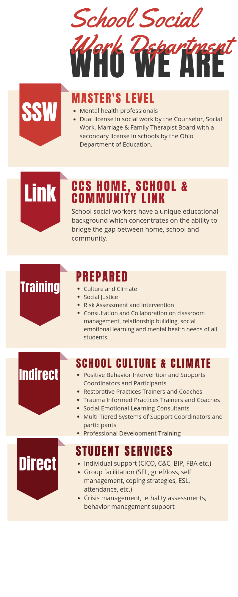

# MISSION & VISION STATEMENTS

|  |  |
| --- | --- |
| CCS District Mission  Each student is highly-educated, prepared for leadership and service, and empowered for success as a citizen in a global community. | School Social Work Mission  To promote and support healthy development in all students by providing resources and services that enhance and promote their educational, social and emotional needs. By removing non-academic barriers students will achieve increased academic success and be prepared for graduation and beyond. |
| CCS District Vision  A world-class model of public education that prepares members of our communities to reach their full potential. | School Social Work Vision  School Social Work is valued as an integral part of the educational process for all students; connecting home, school and the community. |

# 

# NATIONAL SCHOOL SOCIAL WORK STANDARDS

The following eleven standards are adapted from and are a synthesis of the National Association of Social Work (NASW) Standards for Professional Practice, which can be found in their entirety at http://www.naswdc.org. These eleven standards provide the essential foundations guiding social workers’ performance in the school environment. They are consistent with the principles, knowledge and performance practices in delivering school social work services. Fidelity to these significant standards will help staff remain faithful to the mission and philosophy of their profession in delivering social work services in an educational setting. Each of the following standards is organized by definition, principles for guiding practice, content knowledge and performance expectations.

Standard 1. **Ethics and Values**

Standard 2. **Qualifications**

Standard 3. **Assessment**

Standard 4. **Intervention**

Standard 5. **Decision Making and Practice Evaluation**

Standard 6. **Record Keeping**

Standard 7. **Workload Management**

Standard 8. **Professional Development**

Standard 9. **Cultural Competence**

Standard 10. **Interdisciplinary Leadership and Collaboration**

Standard 11. **Advocacy**

*See Appendix 1

# CODE OF ETHICS

School Social Workers must be knowledgeable of the ethical principles and codes of professional conduct described in the National Association of Social Work’s Code of Ethics. In addition, they are also bound to the Ohio Department of Education Code of professional conduct for Ohio Educators. Finally, as school employees, School Social Workers must comply with the Family Educational Rights and Privacy Act (FERPA) and the Health Insurance Portability and Accountability Act (HIPAA). Due to the obligations these professional conduct codes, statutes and regulations impose, a School Social Worker must balance the systemic needs of the school with the privacy needs of students served. As a result, School Social Workers have a responsibility to strike a balance between protecting student privacy and confidentiality, while remaining an important source of contextual information for school staff.

# FERPA

FERPA (Family, Educational Rights and Privacy Act), a federal law, protects the privacy of students and parents by restricting access to, and protecting the confidentiality of, education records. FERPA defines specific rights of parents and students who are 18 years or older regarding their access to, and the confidentiality of, education records. FERPA applies to public schools and other education agencies that receive federal funds. Under FERPA, school officials may disclose personally identifiable information from an education record to other school personnel who have a “legitimate educational interest”. FERPA includes many requirements for safeguarding student information.

*See Appendix 2*

# HIPAA

HIPAA (Health Insurance Portability and Accountability Act) privacy rule. The HIPAA privacy rule governs how health care providers use and disclose “protected health information.” http://www.hhs.gov/ocr/privacy/hipaa/understanding/ index.html. HIPPA includes provisions for allowable disclosures by health care providers under certain circumstances, including, but not limited to, treatment, public health, state law and child abuse.

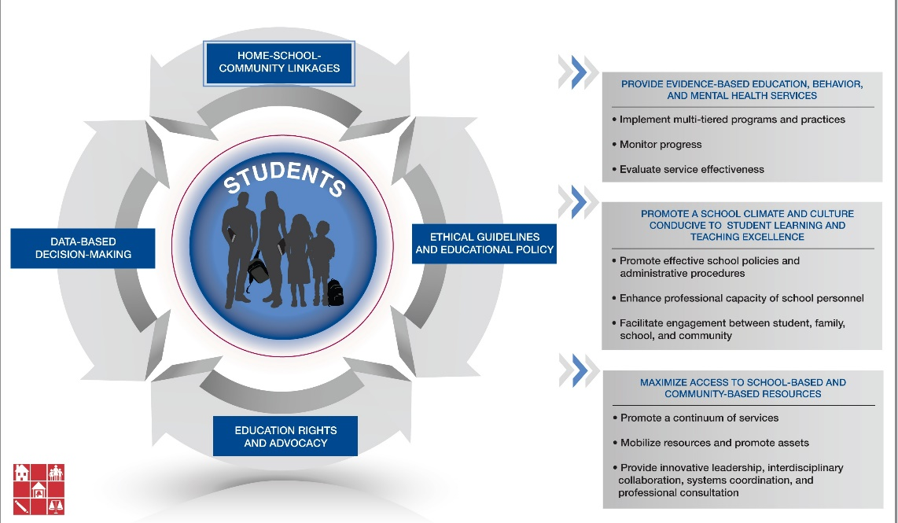

# SCOPE OF PRACTICE OVERVIEW

School Social Workers are part of a larger system addressing the needs of young people, both in school and in the community. As such, they collaborate with a broad network of educators, service providers, parents, administrators and others. Whether working with an individual student or advocating at a policy level, School Social Workers align their intervention with the unique needs of the student and the situation. School Social Workers provide services individually, in small groups or through classroom-based psycho-educational activities. These services are designed to foster the social emotional competencies of school-age children. They are available to classroom staff as a consultant for developmental norms and effective practices to meet student needs in the classroom setting. School Social Workers collaborate with community-based service providers and mental health practitioners to coordinate intervention plans and other services. They also educate families about student needs and assist families in accessing necessary services. The scope of practice School Social Workers use to address non-academic barriers impacting student success include the following: prevention; barrier identification; evaluation; intervention/treatment; collaboration/consultation; advocacy; and linkages to community resources. These procedures, actions and processes ensure a holistic approach to maximizing student achievement for students, parents and educators.

# SCHOOL SOCIAL WORK MENU OF SERVICES

Responsive Services

* Provide HB318 Mental Health Consultation to Administrators prior to suspension/expulsion for PK-3 students.
* Crisis prevention, intervention & response
* Mental Health Triage, Suicide Risk Assessments & Safety Plans
* RTI (Response to Intervention) support & intervention
* Restorative Practice Training & Implementation
* Trauma Informed Care Training & Implementation
* Conflict Resolution Skills
* Behavior Management Strategies and follow up
* Care Team Supports- grief & loss supports to students & staff
* Provide support & guidance to building staff re: student concerns/issues
* Restorative Conversations & creating/providing safe spaces
* Model and teach de-escalation and self-regulation strategies
* FCCS referrals re: child abuse/neglect concerns
* Removing student/family barriers to increase student academic performance and improve family relationships with the school.
* Assist teachers with identifying, creating and implementing appropriate classroom management strategies
* School Truancy filings
* Development of re-entry plans when student return from suspension, expulsion, residential or institutional settings, etc.
* Identifying and creating alternatives for out of school suspension
* Creation & development of school based leadership and mentor programs.

Indirect Services

* Active participants in MTSS/IAT process & 504/IEP planning meetings
* Active participants in HB410 process
* Staff Development
* Resources/Supports
* Coordination and linkage to community resources & supports
* Parent Education &Training
* Collaborative Communication w/ administrators, teachers, other school personnel & family members to ensure the needs of all students are met.
* Collaboration & consultation w/ community agencies/partnerships.
* Implementation and support of restorative strategies
* Building wide PBIS Initiatives- Tiered Interventions, support & guidance
* Work along- side school counselors to provide classroom guidance lessons
* Coordination of service delivery
* Develop systems of accountability between home, school & community.
* Advocate for student rights as related to IDEA, ESSA, McKinney-Vento, etc.
* Educate staff on self-care and team building initiatives to improve morale.
* Classroom observation, feedback, direction and guidance.
* Address student academic, behavioral and attendance concerns impacting literacy, numeracy and graduation
* Create cultural awareness & sensitivity within staff student/family relationships
* Support Office and District Initiatives

Direct Services

* Strategies to increase academic success
* Interventions to improve attendance
* Intervention & supports to increase School Retention & Graduation rates
* Individual & Group Counseling, problem-solving, self-discipline, relationships
* Social Emotional Learning Strategies
* Mental Health Support intervention & knowledge
* Evaluation, assessment & case management services
* Parent & Family Engagement
* Home visits to identify barriers & bridge gap between home, school & community
* Behavior Intervention Plans, Improvement Strategies & Progress monitoring
* Ensure basic needs (housing, food, clothing, electricity, etc.) are met by linking w/ community resources
* Parent phone conferences & face to face meetings supporting ideas to increase student academic & overall success
* Tutoring supports, including reading & math support groups
* College & Career coaching & supports (explain/identify)
* Short & Long term goal planning w/students & progress monitoring
* Identifying student strengths to maximize positive student outcomes
* Life Skills planning/

Implementation for life beyond high school graduation

# COLUMBUS CITY SCHOOLS BOARD POLICIES

School Social Workers are instrumental in the support and implementation of Columbus City Schools Board of Education Policy. CCS Board policies and programs related to students that our School Social Workers frequently advocate under and uphold include:

**POLICIES:**

5111.01 HOMELESS STUDENTS

5111.03 CHILDREN AND YOUTH IN FOSTER CARE

5200 **ATTENDANCE AND TRUANCY**

5350 STUDENT SUICIDE

5451 STUDENT RECOGNITION

5500 STUDENT CONDUCT

5511 DRESS AND GROOMING

5517 ANTI-HARASSMENT

5517.01 **BULLYING AND OTHER FORMS OF AGGRESSIVE BEHAVIOR**

5530 **DRUG PREVENTION**

5610 REMOVAL, SUSPENSION, EXPULSION, AND PERMANENT EXCLUSION OF STUDENT

5610.02 **IN-SCHOOL DISCIPLINE**

5630.01 POSITIVE BEHAVIOR INTERVENTION AND SUPPORTS AND LIMITED USE OF RESTRAINT AND SECLUSION

**PROGRAMS:**

[2111](https://go.boarddocs.com/oh/columbus/Board.nsf/Public?open&id=policies) PARENT AND FAMILY INVOLVEMENT

2114 MEETING STATE PERFORMANCE INDICATORS

[2120 SCHOOL IMPROVEMENT](https://go.boarddocs.com/oh/columbus/Board.nsf/Public?open&id=policies)

2250 INNOVATIVE PROGRAMS

2260 NONDISCRIMINATION AND ACCESS TO EQUAL EDUCATIONAL

OPPORTUNITY

[2260.01 SECTION 504/ADA PROHIBITION AGAINST DISCRIMINATION BASED ON DISABILITY](https://go.boarddocs.com/oh/columbus/Board.nsf/Public?open&id=policies)

2370 EDUCATIONAL OPTIONS

[2411 GUIDANCE AND COUNSELING](https://go.boarddocs.com/oh/columbus/Board.nsf/Public?open&id=policies)

[2412 HOMEBOUND INSTRUCTION PROGRAM](https://go.boarddocs.com/oh/columbus/Board.nsf/Public?open&id=policies)

[2413 CAREER ADVISING](https://go.boarddocs.com/oh/columbus/Board.nsf/Public?open&id=policies)

[2416 STUDENT PRIVACY AND PARENTAL ACCESS TO INFORMATION](https://go.boarddocs.com/oh/columbus/Board.nsf/Public?open&id=policies)

[2421 CAREER-TECHNICAL EDUCATION PROGRAM](https://go.boarddocs.com/oh/columbus/Board.nsf/Public?open&id=policies)

2430 DISTRICT-SPONSORED CLUBS AND ACTIVITIES

[2430.01 SPECIAL PROGRAMS BY COMMUNITY VOLUNTEERS](https://go.boarddocs.com/oh/columbus/Board.nsf/Public?open&id=policies)

2450 ADULT AND COMMUNITY EDUCATION

2460 SPECIAL EDUCATION

2575 SERVICE LEARNING

2605 PROGRAM ACCOUNTABILITY AND EVALUATION

[2623 STUDENT ASSESSMENT AND ACADEMIC INTERVENTION SERVICES](https://go.boarddocs.com/oh/columbus/Board.nsf/Public?open&id=policies)

[2623.01 INTERVENTION](https://go.boarddocs.com/oh/columbus/Board.nsf/Public?open&id=policies)

[2623.02 THIRD GRADE READING GUARANTEE](https://go.boarddocs.com/oh/columbus/Board.nsf/Public?open&id=policies)

# MEASUREMENTS OF SERVICE

School Social Workers continuously measure and assess the effectiveness of their student evaluation and intervention practices. In school settings, the primary focus of data collection is student assessment. Additionally, School Social Workers will also need to evaluate the rigor and effectiveness of the services being provided to students. To measure the value of professional interventions, School Social Workers use a variety of formal and informal tools. These tools may include, but are not limited to:

|  |  |
| --- | --- |
| Formal Tools | Informal Tools |
|  |  |
| Pre & Post Test Measures | Observations, Data Collection |
| Qualitative Research Design  Screening Assessments | Charts of Progress  Teacher/Student/Parent Report |
|  |  |

# SUPERVISION

Supervision is an important requirement for the professional growth of School Social Workers. According to the NASW Standards for School Social Work Services, “The administrative structure established by the local education agency should provide for appropriate school social work supervision.” Due to the nature of an educational setting, School Social Workers are expected to receive supervision at two levels: administrative and professional. The evaluations of CCS School Social Workers will be completed by the Director and Supervisor of the Office of Social Emotional and Student Support Services under the professional supervision level. Administrative supervision, of School Social Workers, refers to the on-site, day-to-day, non-clinical supervision of staff as they perform their general job responsibilities and duties. This supervision does not require a clinical social work supervisory license and can be provided by a school principal or school district administrator. Professional supervision of School Social Workers involves both clinical supervision and discipline specific supervision. Clinical Supervision is the oversight of therapeutic interventions provided by the School Social Worker. This level of supervision is generally provided by a Licensed Independent Social Work Supervisor (LISW-S) or a Licensed Professional Clinical Counseling Supervisor (LPCC-S). Discipline specific supervision refers to the delivery of School Social Work services within the school system. This level of supervision promotes professional competence and ensures high-quality social work services are provided to students, families, school staff and the community. Overall, discipline specific supervision contributes to and guides the professional growth and development of the School Social Worker. The Supervisor and Director of the Office of Social Emotional and Student Support Services will provide additional supports to all School Social Workers to include but not limited to:

* Providing information about community resources
* Liaison to administrators to help them understand School Social Work roles, responsibilities and practice.
* A support to School Social Work staff
* Teaching strategies that enhance the School Social Worker’s ability to effectively function as a part of the educational team.
* Serve as a link between all School Social Workers, as well as the link between School Social Workers and other district support staff
* Develop procedures that standardize practice
* Educate and advocate for school social work practice within the school and community.
* Provide professional development opportunities to include, staff meetings, conferences, workshops, etc. to promote self-awareness and continued professional growth.
* Conduct school social work annual ILEAD evaluations.

# SCHOOL SOCIAL WORKER ASSIGNMENTS

There are currently 40 School Social Workers employed by Columbus City Schools. In order to best serve the needs of over 110 elementary schools, middle schools, high schools and programs, School Social Work assignments are re-evaluated annually. On average, CCS School Social Workers are assigned to serve anywhere from one to five school buildings. Buildings that do not have a weekly School Social Worker will be assigned a social worker to assist on a referral basis. In order to serve each building to optimal capacity, each School Social Worker is expected to have access to the following items within their assigned school buildings:

* An identified and consistent work space that allows for confidentiality when meeting w/students and families and when making confidential phone calls.
* A desk, Wi-Fi, chair and phone
* A filing cabinet or desk that can be locked

# SCHOOL SOCIAL WORKER - REFERRAL SCHOOLS

In an attempt to service all CCS buildings some schools are assigned School Social Workers on a referral basis. School Social Workers are expected to reach out to their referral school at the beginning of the school year to establish a working relationship. It is expected that the School Social Worker will identify the key contact people in the building and the best methods of communication between themselves and their assigned referral school. The referral school should be clear and comfortable with the agreed upon referral process and be encouraged to reach out when student needs arise. In order to provide ongoing support, School Social Workers are expected to be in contact with their referral school, at least, monthly to check-in, consult with and be available to address student needs. All in all, School Social Workers are available to serve referral schools in the following capacity (this is not an inclusive list, if in doubt please reach out):

* Assist with home visits regarding “No Show” Students
* Unable to Locate Forms: Can assist w/Swkr Consult, ODDEX check, Home visits
* Addressing Non-Academic barriers- homelessness, lack of basic needs, grief/loss, teen parenting, family trauma, etc.
* Linking students and families to community resources
* Crisis Prevention/Intervention- including Suicide Lethality Assessments
* HB318 and HB 410 Consultation
* Provide support & guidance to staff re: student concerns/issues
* Home visits to identify and address barriers to bridge gap between home & school
* School Truancy Filings
* General consultation

# NEW HIRE MENTOR

Newly hired School Social Workers are matched with a mentor. The mentor is a current School Social Worker who has at least three years of experience working with Columbus City Schools. The mentor will be responsible for training the new hire around school social work practices, district procedures and policies. The mentor will support the new school social worker for one full school year, answering any questions and guiding them throughout their first year of employment. During that first year, the new School Social Worker will have the support and guidance of both a district School Social Work Mentor and a PAR Consultant. Mentors are matched based on numerous factors, including previous experience and involvement with the schools assigned to the new hire.

# SCHOOL SOCIAL WORK IN THE MTSS FRAMEWORK

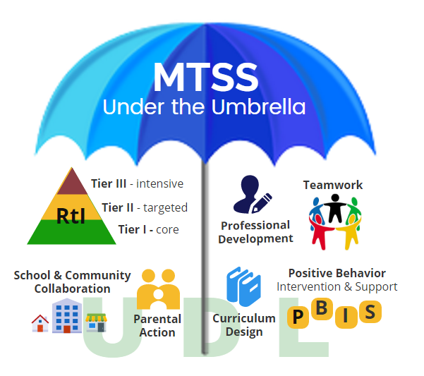

Multi-Tiered Systems of Support (MTSS) is a framework that schools use to provide targeted supports to all students. It focuses on the “whole child.” MTSS supports academic growth and achievement, but it also supports students in many other areas.

**School Social Workers assist the educational mission of their school and district through tiered interventions designed to meet the needs of all students.** The MTSS approach considers environmental factors as they apply to an individual student’s difficulty, and provides service/intervention as soon as the student demonstrates a need. School Social Workers assist in the tiered level process as identified.

**Tier 1** refers to evidence-informed, school-wide prevention programs and practices that teach positive behaviors, promote social-emotional development, and ensure a school climate conducive to learning. Tier 1 programs and practices are implemented by all staff in the school setting. Ongoing data-informed decision making ensures that Tier 1 interventions are effective.

**Tier 2** refers to the use of evidence-informed, small group, and short-term interventions focused on improving early academic and social–emotional engagement to reduce problem behavior and increase desired academic and behavioral outcomes. For example, these interventions could target conflict resolution, social skills, mental health needs, and short-term crisis situations that do not require more intensive tier 3 interventions. On the basis of data demonstrating a lack of response to tier 1 interventions, students are referred for the additional support offered at tier 2.

**Tier 3** refers to the use of evidence-informed individual and long-term interventions. Tier 3 interventions are provided to students who have serious academic, behavioral, or social–emotional needs. The goal of this tier is to address the identified need and provide individual strategies to increase the student’s overall functioning and academic performance. Tier 3 interventions are intensive and may be implemented for extended periods of time, frequently involving community agencies. Data from tier 3 interventions may indicate the need to consider eligibility for special education services.” (NASW Standards for School Social Work Services, Michelle Alvarez, MSW, Eddy, LICSW, C-SSWS, et. al. 2012)

*\*Examples of Responsive, Direct and Indirect services provided by School Social Workers in each of the three tiers are outlined on the next three pages (not an inclusive list)*.

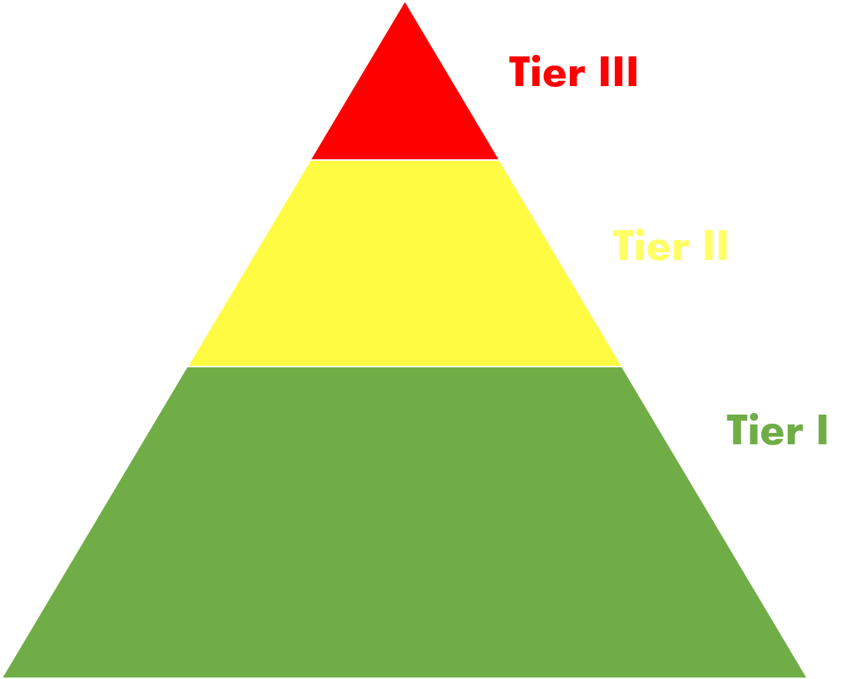

Responsive Services provided by CCS School SOCIAL WORKERS

**Tier 3:**

* Suicide Risk Assessments and Safety planning
* Assist CARE Team members with crisis response after death of a student/staff member.
* FCCS referrals regarding child abuse/neglect
* School Truancy Filings
* Develop re-entry plans for students returning from Detention, Hospitalization, Residential Treatment, Suspension and/or Expulsion

**Tier 2:**

* Conflict Mediation/Resolution
* Provide De-Escalation and self-regulation strategies
* Identify and create alternatives to out of school suspension
* Develop Student Leadership and Mentoring Programs

**Tier 1:**

* Restorative Practice Training and Implementation
* Trauma Informed Practices Training and Implementation
* Training and support on classroom management
* Removing barriers and creating a safe space for students and families allowing for academic focus
* Provide support to staff for self-care and team building

**(not an inclusive list)**



**Tier 1:**

* Parent and Family Engagement /Parent Education and Training
* Teaching of school-wide expectations
* Coordination of community resource fairs
* Ensure basic needs are being met (food, clothing, shelter)

**(not an inclusive list)**

# Direct Services provided by CCS School Social WorkerS

**Tier 2:**

* Group work (study skills; grief/loss; anger management, emotional regulation; conflict resolution; social skills; peer mediation; teen parenting; etc.)
* Tutoring supports including reading and math groups
* Check in/Check out (CICO)
* Signs of Suicide Intervention and Prevention
* Refer and link students to Community Mental Health Providers (Directions for Youth and Families, Nationwide Children’s Hospital, The Buckeye Ranch, Youth Advocate Services, etc.)
* Truancy Diversion Programming

**Tier 3:**

* IAT Participant/Coordinator
* HB410 Participant
* Home visits
* Evaluation, Assessment and Case Management Services
* Crisis Counseling and Support
* Signs of Suicide Program Support
* Individual Counseling
* Advocacy for student rights related to McKinney-Vento, IDEA, ESSA, etc.
* Collaborate with other SSW and staff regarding sibling & family concerns



# Indirect Services provided by CCS School Social Workers

**Tier 2:**

* Collaborate with teachers to develop classroom behavioral interventions and accommodations
* Student Leadership Initiatives (Link Crew, Student Council, Student Ambassadors, etc.)
* Implementation and support of Restorative Practice
* Implementation and support of Trauma Informed Practices

**Tier 3**:

* Assist with Functional Behavior Assessments (FBA)
* Assist with Behavior Intervention Plans (BIP)
* Direct support to building staff
* Coordination of crisis response

**Tier 1:**

* PBIS Team Member/Coordinator
* MTSS Team Member
* TBT/BLT Member
* Staff Development/In-Service Training on various topics including PBIS, Trauma Informed Practices, Restorative Practices, Child Abuse identification and reporting, Suicide Prevention, Grief and Loss, Classroom Management, etc.)
* Plan and Coordinate School Wide Awareness/Prevention Activities (Child Abuse Prevention, Start with Hello, Say Something Week, Red Ribbon Week, etc.)
* Build Community Partnerships
* Coordinate with Community Service Providers (Health Department Groups, Food Pantry programs, etc.)
* Develop Cultural Awareness and Sensitivity within the school community

**(not an inclusive list)**

# POSITIVE BEHAVIOR INTERVENTION AND SUPPORTS (PBIS)

As previously noted, School Social Workers provide intervention and support within the MTSS Framework and are valuable members of the building PBIS Teams. PBIS falls under the MTSS Framework wherein School Social Workers are instrumental in providing direct, indirect and responsive services to members of the school community in tiers 1, 2 and 3. Key components of PBIS include preventive activities (i.e. teaching, re-teaching and modeling school-wide expectations), data-based decision making, and problem solving. PBIS is required of all Columbus City Schools as part of the Ohio Improvement Process. PBIS is also required under IDEA and House Bill 318.

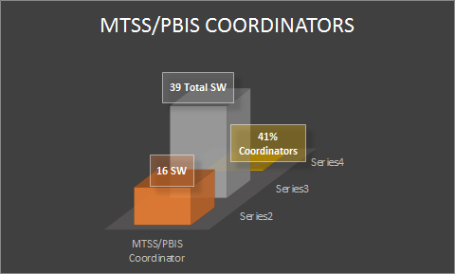

16 out of 39 school social workers served as MTSS/PBIS Coordinators during the 2018/19 SY.  This aligns with Priority #3 of the District's Strategic Plan which is to establish strong culture and climate.

# TRAUMA INFORMED PRACTICES

Trauma informed practices are interwoven throughout the tiers of support in both PBIS and RTI. “A [trauma-informed school](https://traumasensitiveschools.org/) is one in which all students and staff feel safe, welcomed and supported and where the impact of trauma on teaching and learning is addressed at the center of the educational mission. Trauma-informed schools create school policies, practices and cultures that are sensitive to the needs of traumatized individuals and ensure that all individuals (students, families and staff) meet their maximum potential.” (Ohio Department of Education: <http://education.ohio.gov/Topics/Student-Supports/PBIS-Resources/Trauma-Informed-Schools>).

Trauma Informed Practice sits within the Common Instructional Framework of Social Emotional Learning. This district initiative is supported by the Office of Social Emotional and Student Support Services. Through a partnership with Akron Children’s Hospital, many CCS School Social Workers have become Trauma Informed Trainers. The goal of being trauma informed is to create awareness and empathy around the effects of trauma on students. One of the benefits of developing trauma informed staff is that students will be afforded the opportunity to self-regulate w/ the least amount of classroom disruption. As staff become more conscious and socially aware of the ways in which trauma impacts a student’s ability to focus on academics, empathy is developed and strategies are utilized to create policies and practices that are sensitive to the needs of traumatized students. School Social Workers continue to advocate for healthy and safe spaces in the student learning environment, by providing trainings surrounding the following trauma concepts:

* Introduction to Trauma
* Managing Trauma in the classroom
* Increasing Developmental Assets in Children
* Recognizing Secondary Traumatic Stress

# RESTORATIVE PRACTICES

Restorative practices are also interwoven throughout the tiers of support in both PBIS and RTI. Columbus City Schools has taken steps to embrace Restorative Practices. The oversight and development of this district initiative lies within the Office of Social Emotional and Student Support Services and is led by one of Columbus City Schools district employed School Social Workers. Restorative Practice sits within the Common Instructional Framework of Social Emotional Learning. The district has worked closely with the International Institute for Restorative Practices (IIRP) to develop district trainers to continue to implement and support the ongoing learning of Restorative Practices throughout Columbus City Schools. The most important concept behind the Restorative Practice framework is the importance of building positive relationships. In fact, IIRP teaches that, “the aim of restorative practice is to develop community and to manage conflict and tensions by repairing harm and restoring relationships”. The concepts that make up the foundation of IIRP’s restorative trainings are:

* Explicit Practice * Social Discipline Window

* Fair Process * Psychology of Affect and Compass of Shame

* Restorative Practice Continuum * Affective Statements

* Restorative Questions * Restorative & Pro-active Circles.

All in all, School Social Workers play an integral role in the staff development and training of Restorative Practices in elementary, middle and high schools throughout Columbus City Schools.

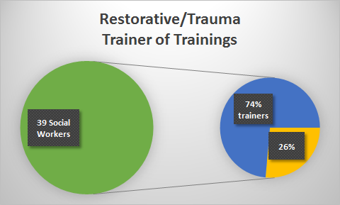

**Restorative Practices and Trauma Informed Care strongly align with the Social Work Discipline; thus causing school social workers to be the leading Trainer of Training in our district. Seventy-four percent (74%) of Columbus City School social workers are meeting the district’s strategic plan to provide a strong culture and climate by ensuring that administrators, certificated and classified staff receive job embedded professional development that improves teacher and student outcomes.**

# HOUSE BILL 318

House Bill 318 acknowledges the importance of districts adopting and implementing Positive Behavior Intervention and Supports (PBIS) and Social Emotional Development. This Bill clarifies that districts must implement a PBIS framework system-wide. It also specifies that district “zero tolerance” policies must comply with PBIS provisions. This Bill also identifies specific provisions regarding “all student” discipline procedures as well as discipline procedures specific to grades PK-3. A big change initiated by HB 318, starting with the 2019-2020 school year, notes “whenever possible, the principal is required to consult with a mental health professional under contract with the district or school before suspending or expelling a student in grades Pk-3”. This change is significant to School Social Workers because every School Social Worker employed by Columbus City Schools holds a professional mental health license.

*Please see Appendix 3 for more information on House Bill 318.*

# HOUSE BILL 410

House Bill 410 encourages and supports a preventative approach to working with students who have excessive absences and truancy. Schools are required to develop Attendance Intervention Teams (AIT) to intervene with students who are struggling with attendance. As stated in House Bill 410, “The district may invite a school psychologist, counselor, social worker, representative of a public or nonprofit agency or representative from the court to participate on the team”. As buildings develop their Attendance Intervention Teams (AIT), it’s important to consider the following: “Membership of each team should vary based on the needs of each individual student, but each team MUST include: a representative from the student’s school or district; another representative from the school or district who has a relationship with the child; the child’s parent (parent’s designee) or the child’s guardian, custodian, guardian ad litem or temporary custodian.”

Ultimately, when issues of basic needs, mental health concerns, or safety arise a referral to the School Social Worker should be made.

*Please see Appendix 4 for more information on House Bill 410.*



# ROLE OF THE SCHOOL SOCIAL WORKER AS COURT LIAISON:

* Acts as the representative of Columbus City Schools in truancy and educational neglect court proceedings
* Check the court docket weekly to determine schedule of preliminary hearings and trials
* Review and verify information provided on filings prior to court
* Review School Social Worker information prior to court and provide information during the proceedings
* Meet with families, if possible, prior to court proceedings to provide linkages to resources
* Document outcome during any proceedings including any future hearing dates
* Attend all preliminary hearings as well as additional hearings that are scheduled during the preliminary hearings
* Check with court and prosecuting attorney to determine outcome on all Truancy and Ed. Neglect cases
* Document results of all court proceedings in Infinite Campus
* Collaborate with School Social Workers regarding student cases and outcomes
* Complete reports and other documentation as requested by supervisor
* Process subpoenas

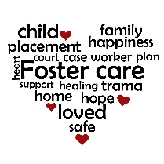

# ROLE OF THE SCHOOL SOCIAL WORKER AS FOSTER CARE LIAISON

* Foster Care Point of contact
* Streamline enrollment process for students in foster care
* Participate in Best Interest Determination of school placement for foster placed student
* Review information on students placed in foster care
* Notify School Social Worker, School Counselor & Building Administrator of students placed in foster care within their building
* Alert School Social Workers & Counselors of needs of foster placed youth, if applicable
* Work cooperatively with child welfare agency/partners
* Assist in coordination of withdrawal, records transfer for foster placed students
* Provide foster care related training /information to the district
* Serve as communication link between foster care agency, child welfare agency and schools in regards to foster placed students
* Provide assistance with transportation for foster placed youth
* Gather & track data on foster placed students
* Complete reports & documentation as required



**.**

**School Social Worker**

* Dual license (Ohio Social Work and Ohio Department of Education)
* Home-School-Community Liaison
* Direct Services (individual/group therapeutic services, social and emotional learning)
* Mental Health Professional
* Professional Case Management
* Consultation for Behavior Intervention Plans
* Ability to provide mental health counseling
* Trained in trauma and restorative practices
* Collaborate with community supports (mental health agencies, child welfare and juvenile justice)

# ccs student support services

**School Social Worker and School Psychologist**

* IEP Services
* Behavioral Assessments
* Behavior Contracts
* Social emotional assessments

**School Social Worker, School Counselor and School Psychologist**

* MTSS Team
* Problem Solving Team
* Crisis Intervention
* Consultation
* Parent Education
* Classroom Presentation

**School Psychologist**

* Evaluations (intelligence, achievement, adaptive, cognitive processing)
* Consultation

**School Social Worker and School Counselor**

* Behavior Supports
* MTSS coordinators
* Teacher supports
* PBIS coordinators
* Lethality assessment
* School Climate and Culture
* Community Collaboration
* Staff Consultation
* Individual & Group Counseling

**School Counselor**

* Orientation and Transition Services
* Cumulative records and scheduling
* Large group standardized assessments
* Guidance curriculum and affective class presentations

**School Counselor and School Psychologist**

* Learning appraisal
* Educational collaboration

# BIBLIOGRAPHY

Horner. (2000). Lewis & Sugai. (1999). Sugai et.al. (2000). Weigle. (1997). Focus on Exceptional Children “Examining the Evidence Base for School-Wide Positive Behavior Support”. <http://www.cast.org/whats-new/news/2016/udl-in-the-essa.html#.XWA59ui6PIU>

Michelle Alvarez, MSW, EdD, LICSW, C-SSWS, et. al. (2012). NASW Standards for School Social Work Services. [https://www.socialworkers.org](https://www.socialworkers.org/).

Connecticut State Department of Education. (2013). Practice Guidelines for Delivery of School Social Work Services: Promoting the Social-Emotional Competencies of Students-Linking Families, Schools and Communities.

<https://portal.ct.gov/-/media/SDE/Publications/school_social_work/school_social_work.pdf->

Ohio Department of Education Website. <http://education.ohio.gov/>

US Dept. of Education- <https://www2.ed.gov/policy/gen/guid/fpco/ferpa/index.html>

School Social Work Association of America. <https://www.sswaa.org/>

Columbus City Schools. <https://portal.ct.gov/-/media/SDE/Publications/school_social_work/school_social_work.pdf->

Killian S. (2015). 8 Strategies Robert Marzano and John Hattie Agree Upon. www.evidencebasedteaching.org.au/robert-marzano-vs-john-hattie/

# APPENDIX

1. NASW Standards for School Social Work Practice
2. FERPA
3. House Bill 318
4. House Bill 410
5. Resources for School Social Workers

**National School Social Work Standards**

|  |  |  |  |
| --- | --- | --- | --- |
| **STANDARDS** | **PRINCIPLES** | **KNOWLEDGE** | **PERFORMANCE** |
| **Standard 1:**  **ETHICS & VALUES**  (These principles serve as the basis for all SSW standards.) | Demonstrate Core Values:  Columbus City School Social Workers are committed to pursuing their mission by embracing the core values of the Social Work Profession:   * Belief in the dignity and worth of all people * Importance of human relationships * Commitment to service * Pursuit of social justice * Competence in all aspects of professional practice * Integrity in all professional interactions   • NASW Code of Ethics is used as a guide for professional & ethical decision making | • Human behavior in the social environment, including theoretical perspectives related to human growth and development, learning, systems, communications, social learning and behavior  • The broad range of experiences that shape a student’s approach to learning, i.e.: development, biological factors, socioeconomic status, gender, culture, disability and sexual orientation  • The needs of at-risk children and children with disabilities  • Local state and federal mandates related to confidentiality and ethical decision making  • Research- and evidence-based practices. | • Develop helping relationships with diverse populations and cultural groups, students, families and communities  • Facilitate, engage in and demonstrate a variety of prevention, intervention and educational activities  • Provide student services in ways that build students’ individual strengths and offer students maximum opportunity to participate in the planning and direction of their own learning experience  • Protect the legal rights and confidentiality of students, their families and other vulnerable groups  • Possess and use professional judgment in order to adhere to the NASW Code of Ethics, which results in ethical decision making. |
| **Standard 2:**  **QUALIFICATIONS** | • Master’s Degree in Social Work  • Licensed by the Ohio Counselor, Social Work and Marriage & Family Therapist Board  • School Social Work Specialization  • Ohio Department of Education Professional License. | • The organization and structure of the local education system;  • The relationship between practice and policies affecting students;  • Evidence-informed approaches to teaching & learning that promote positive academic outcomes for all students. | • Identify areas of need not being addressed by local education agencies/community and work to create services to address these needs;  • Develop & provide services that address the goals and mission of the educational institution and its academic standards;  • Assist in the development of school improvement plans that include the expansion of school resources. |

|  |  |  |  |
| --- | --- | --- | --- |
| **STANDARDS** | **PRINCIPLES** | **KNOWLEDGE** | **PERFORMANCE** |
| **Standard 3:**  **ASSESSMENTS** | • Objective Assessments of individuals, families and systems/organizations (i.e.: classroom, school, neighborhood, district, state). | • Methods of systematic assessment & data gathering skills.  • The functional approach to assessment as it relates to behavior and interventions;  • The potential biases in assessment approaches with students of diverse racial, ethnic and cultural experiences;  • The state and federal laws and regulations regarding students with special needs (e.g., Section 504 of the Rehabilitation Act of 1973, Individuals with Disabilities Education Act, etc.) | • Collect and analyze data systematically through standardized instruments, records review, interviews and observations, etc.;  • Develop appropriate interventions and educationally relevant recommendations based on data review.  • Analyze existing data systems (e.g., attendance, behavior and academic records) to create plans that will assist students in their overall functioning.  • Ultimate goal of improving student social, emotional, behavioral and academic outcomes. |
| **Standard 4:**  **INTERVENTION** | • Supportive adult relationships to increase successful student outcomes;  • Students and families as major stakeholders in intervention plans;  • Interventions based upon the student’s existing strengths;  • Clinically appropriate interventions  • Culturally and linguistically competent practice. | • Levels of service (individual, group, family or system interventions)  • Scope of service (primary, secondary and tertiary prevention and intervention efforts)  • Theoretical perspectives such as behavioral, cognitive, psychodynamic, family systems, strength-based, ecological, crisis intervention and conflict resolution. | • Develop positive working relationships with students, their families, school staff and administration;  • Select, implement and evaluate appropriate intervention methods based on assessments and empirical evidence that will enhance a student’s learning capacity;  • Run psycho-educational groups within the school setting;  • Recognize and intervene with students’ mental health problems, such as depression, anxiety and self-injurious behavior. |

|  |  |  |  |
| --- | --- | --- | --- |
| **STANDARDS** | **PRINCIPLES** | **KNOWLEDGE** | **PERFORMANCE** |
| **Standard 4:**  **INTERVENTION**  **(Continued)** |  |  | • Assess and intervene with students exhibiting behavioral problems, such as disruptive behavior, substance abuse and bullying;  • Intervene in crises and offer appropriate counseling services or community referrals for all those affected;  • Recognize and intervene appropriately with traumatized children, their families, and school staff;  • Design interventions to promote positive educational experiences and involve the student, family, school personnel and community services when appropriate  • Use collaboration and consultation with other professionals to assist in designing and evaluating intervention plans. |
| **Standard 5:**  **DECISION MAKING & PRACTICE EVALUATION** | • Use data to guide service delivery  • Use data to evaluate practices | • Data drives interventions and helps determine outcome measures.  • Consistent evaluation of practice strategies can increase alignment to student success. | • Collect, analyze, synthesize & disseminate data related to practice  • Conduct ongoing evaluations to determine effectiveness of interventions  • Periodically review evaluation methods to ensure outcomes are aligned with district goals and social work ethical practice. |

|  |  |  |  |
| --- | --- | --- | --- |
| **STANDARDS** | **PRINCIPLES** | **KNOWLEDGE** | **PERFORMANCE** |
| **Standard 6:**  **RECORD KEEPING** | • Shall maintain accurate data and records, relevant to planning, implementation & evaluation of School Social Work Practice | • Documented interventions demonstrate service delivery and outcomes.  • Timely documentation promotes accountability to both school and community. | • Maintain timely, accurate and confidential records that document school social worker services.  • Records shall be maintained according to federal, state and local laws. |
| **Standard 7:**  **WORKLOAD**  **MANAGEMENT** | • Organize work load to fulfill school & district responsibilities  • Clarify critical social work roles within the mission of the school or district | • Efficiency, intentionality and follow up are essential in demonstrating good social work practice.  • Importance of organization and completion of tasks | • Manage workload in an efficient and effective manner.  • Priorities of practice to be developed collaboratively between the SSW and Supervisor  • Roles & responsibilities performed across a multi-tiered framework for service delivery.  • Use technology to enhance communication, obtain and organize information, demonstrate accountability and complete workload assignments. |
| **Standard 8:**  **PROFESSIONAL DEVELOPMENT** | • Keeping current with developing educational and social trends affecting the lives of children  • Keeping skills current with best practices in school social work  • Maintaining credentials and knowledge base regarding school social work practice  • Continuing self-assessment, evaluation and professional development  • Contributing to the advancement of the profession. | • Reforms in education, school social work and evidence-based models of practice;  • Limits and boundaries of professional roles within the educational system and the community  • Opportunities for continuing education. | • Actively use supervision, collaboration, consultation and professional development to support areas of professional growth;  • Provide educational opportunities for students, parents, other professionals and the community;  • Contribute to the development of the profession by educating and supervising school social work interns and other social workers  • Actively participate in professional associations. |

|  |  |  |  |
| --- | --- | --- | --- |
| **STANDARDS** | **PRINCIPLES** | **KNOWLEDGE** | **PERFORMANCE** |
| **Standard 9:**  **CULTURAL COMPETENCE** | •·Demonstrating self-awareness, knowledge, and practice skills consistent with the NASW Standards for Cultural competence in Social work Practice.  •Shall use evidence-based practices, skills, and techniques that reflect the worker’s understanding of the role of culture in the helping process  •Support an environment that honors and celebrates the cultures of the population within the school. | •Identify cultural barriers impacting student’s academic success.  •Understanding about cultural groups served within the school district.  • Linkage of families to culturally appropriate community resources.  • Identify and educate others on implicit and explicit bias as it relates to cultural sensitivity and competence. | • Ensure students and families are provided services within a culturally competent framework that enhances the students educational success  •Actively participate and provide professional development to staff regarding cultural competency. |
| **Standard 10:**  **INTER-DISCIPLINARY LEADERSHIP & COLLABORATION** | • Broad-based collaboration and cooperation both within the school and the community  • Incorporating family input into developing plans and interventions to address student needs  • Expanding the availability of resources to enhance student and family functioning  • Enhancing the functioning of the individual/family within the community  • Promoting comprehensive prevention programs. | • Community resources and their availability to provide appropriate services  • The reciprocal influences of home, school and community  • The importance of appropriate and culturally sensitive modeling of behavior by school staff and administrators  • The diverse cultures and cultural factors that influence student and family relationships with schools  • Preventive practices and programs | • Develop and maintain positive, constructive relationships with school- and community-based professionals  • Facilitate trusting and cooperative relationships between students, parents, school, and community  • Work collaboratively to mobilize community resources to meet the needs of students and families  • Empower families to effectively use and gain access to educational and community services  • Communicate with school personnel regarding family and community influences on student performance |

|  |  |  |  |
| --- | --- | --- | --- |
| **STANDARDS** | **PRINCIPLES** | **KNOWLEDGE** | **PERFORMANCE** |
| **Standard 11:**  **ADVOCACY** | • Ensure all students have equal access to education & services to enhance their academic success | • Informed about court decisions, legislation, rules/regulations, policies and procedures that impact the school social workers ability to effectively advocate for students.  • Knowledge of local, state & federal resources to support student & family needs. | • Help families gain access to formal & informal community resources  • Educate & assist students and families in developing self-advocacy skills.  • Serve as change agents by identifying student/family unmet needs & coordinating services to address those needs. |

Family Educational Rights and Privacy Act (FERPA)

The Family Educational Rights and Privacy Act (FERPA) (20 U.S.C. § 1232g; 34 CFR Part 99) is a Federal law that protects the privacy of student education records. The law applies to all schools that receive funds under an applicable program of the U.S. Department of Education.

FERPA gives parents certain rights with respect to their children's education records. These rights transfer to the student when he or she reaches the age of 18 or attends a school beyond the high school level. Students to whom the rights have transferred are "eligible students."

* Parents or eligible students have the right to inspect and review the student's education records maintained by the school. Schools are not required to provide copies of records unless, for reasons such as great distance, it is impossible for parents or eligible students to review the records. Schools may charge a fee for copies.
* Parents or eligible students have the right to request that a school correct records which they believe to be inaccurate or misleading. If the school decides not to amend the record, the parent or eligible student then has the right to a formal hearing. After the hearing, if the school still decides not to amend the record, the parent or eligible student has the right to place a statement with the record setting forth his or her view about the contested information.
* Generally, schools must have written permission from the parent or eligible student in order to release any information from a student's education record. However, FERPA allows schools to disclose those records, without consent, to the following parties or under the following conditions (34 CFR § 99.31):
  + School officials with legitimate educational interest;
  + Other schools to which a student is transferring;
  + Specified officials for audit or evaluation purposes;
  + Appropriate parties in connection with financial aid to a student;
  + Organizations conducting certain studies for or on behalf of the school;
  + Accrediting organizations;
  + To comply with a judicial order or lawfully issued subpoena;
  + Appropriate officials in cases of health and safety emergencies; and
  + State and local authorities, within a juvenile justice system, pursuant to specific State law.

Schools may disclose, without consent, "directory" information such as a student's name, address, telephone number, date and place of birth, honors and awards, and dates of attendance. However, schools must tell parents and eligible students about directory information and allow parents and eligible students a reasonable amount of time to request that the school not disclose directory information about them. Schools must notify parents and eligible students annually of their rights under FERPA. The actual means of notification (special letter, inclusion in a PTA bulletin, student handbook, or newspaper article) is left to the discretion of each school.

For additional information, you may call 1-800-USA-LEARN (1-800-872-5327) (voice). Individuals who use TDD may use the [Federal Relay Service](https://www2.ed.gov/about/contacts/gen/index.html#frs).

Or you may contact us at the following address:

Family Policy Compliance Office  
U.S. Department of Education  
400 Maryland Avenue, SW  
Washington, D.C. 20202-8520

**Communities**



**Using House Bill 318 Requirements to Create Caring**

There is tremendous excitement and momentum building in Ohio around Positive Behavioral Interventions and Supports (PBIS) and the importance of school climate to student success. Ohio’s recently adopted strategic plan for education, *Each Child, Our Future*, explicitly recognizes the need for a positive climate in every school to support student well-being, academic achievement and future success. Most recently, Ohio enacted the *Supporting Alternatives for Fair Education (SAFE) Act*, House Bill 318. It is one of the strongest state laws in the country addressing multi-tiered behavioral supports in the interest of reducing disciplinary referrals, especially for prekindergarten through grade 3 students. This bill strengthens requirements for school districts to implement PBIS, social-emotional learning supports and trauma-informed practices. Supported by new legislative mandates, the Ohio Department of Education is enthusiastic to continue building statewide capacity to implement PBIS.

[**Positive Behavioral Interventions and Supports**](http://education.ohio.gov/Topics/Student-Supports/PBIS-Resources) is a framework that guides districts and schools in in developing policies and practices that proactively define, teach and support appropriate behavior. PBIS suggests a shift in thinking about behavior and discipline. Rather than telling students what NOT to do, emphasis is placed on *teaching* students what TO do. Schools implementing PBIS actively teach behavioral expectations across all environments, promote positive behavior through encouragement and reinforcement, and provide correction of inappropriate behavior through prompting, re-teaching and opportunities to correct behavior. PBIS creates consistent, predictable learning environments that increase positive behavior and academic outcomes for each student.

The results of these measures are evident. Ohio schools implementing PBIS with fidelity have demonstrated noteworthy reductions in their rates of office discipline referrals, suspensions and expulsions. With these reductions, administrators and teachers have more time to focus on academic progress, students who previously were removed from the academic environment now spend more time receiving direct instruction, and decreased behavior distractions in the classroom increases academic instruction time for other students in the classroom.

Gov. Kasich signed HB 318 in August 2018, with an effective date of Nov. 2, 2018. Broadly, this act:

* Specifies requirements for the implementation and training of Positive Behavioral Interventions and Supports and other social-emotional programs for students;
* Outlines parameters for the suspension and expulsion of students, particularly for students in grades prekindergarten through grade 3;
* Specifies details regarding the role and training of school resource officers; and
* Provides grant funding for school safety training and school climate.

**Please see the following Frequently Asked Questions regarding this act.**

1. **What are the main components of HB 318?**

HB 318 formalizes preventative and supportive school safety, discipline and climate policies and practices. Find the act and the [official legislative analysis here.](https://www.legislature.ohio.gov/legislation/legislation-documents?id=GA132-HB-318)

**POSITIVE BEHAVIORAL INTERVENTIONS AND SUPPORTS**

1. **What is Positive Behavioral Interventions and Supports (PBIS)?**

PBIS is a schoolwide systematic approach to embed evidence-based practices and data-driven decision making to improve school climate and culture to achieve improved academic and social outcomes and increase learning for all students. PBIS encompasses a wide range of systemic and individualized positive strategies to reinforce desired behaviors, diminish reoccurrences of challenging behaviors and teach appropriate behavior to students. PBIS is a framework that supports the needs and culture of the school by helping school personnel adopt and organize evidence-based behavioral interventions into an integrated continuum that enhances academic and social behavior outcomes for all students.

Implementation of locally selected interventions and systems will create positive behavioral outcomes for students and safe and supportive cultures in schools. These prevention-oriented programs help school personnel adopt and organize evidence-based behavioral systems into an integrated continuum that enhances academic and social behavior outcomes for all students. The administrators, teachers and students should choose the interventions and supports that will improve behaviors and enhance their unique culture.

1. **What is the structure of the PBIS framework?**

The PBIS framework provides a continuum of behavioral intervention supports based on a three-tiered model or multi-tiered system of support (MTSS). The three-tiered framework provides for all students to receive behavioral instruction supports at the universal tier (Tier I). Building a universal set of clearly defined and positively stated behavioral expectations is the core of the process that applies to all students, all staff and all settings. The second level of the continuum (Tier II) focuses on at-risk students who need more than universal supports for behavioral success. PBIS provides interventions for this targeted group of students. The third level of support is individualized and intensive (Tier III) for students who need more personalized assistance. For the successful implementation and sustainability of this multi-tiered system of behavioral supports, a staff consensus and administrative support is essential.

1. **Do we have to eliminate other initiatives if we begin with schoolwide PBIS?**

No. Effective programs and practices currently in place in the school can become part of the schoolwide PBIS system. Schoolwide PBIS will allow for consistency in these practices. PBIS is the sum of effective programs, interventions and support. PBIS will improve the intentionality of working on other areas of need.

1. **Does PBIS mean we will no longer provide consequences for negative behavior?**

PBIS is proactive in teaching behavior expectations and providing positive reinforcement to reduce negative behavior. However, PBIS does not ignore inappropriate behavior. PBIS supports developmentally appropriate consequences that are designed to improve student behavior. Through the PBIS process, schools develop a consistent schoolwide plan for inappropriate behavior that matches consequences to the severity of the inappropriate behavior to maintain consistency across the school and district.

1. **How long will it take to implement PBIS?**

After school staff is trained, the length of time it takes to get started varies by school. Schools typically take two to three years to fully implement all three tiers of PBIS. The process is ongoing and constantly adapted to meet the changing needs of the school and address current concerns. Many schools begin noticing improvements right away. However, it may take a few years to change the school’s culture and climate regarding the handling of inappropriate behavior.

1. **What are the desired results of PBIS?**

The results of PBIS include the following:

* 1. Preventing chronic behavioral challenges.
  2. Providing early intervention for children and youth displaying minor but repeated patterns of problem behavior.
  3. Providing proactive supports to children and youth at risk and those with emotional disturbances to allow them to successfully remain in the general education environments with the appropriate supports.
  4. Providing instruction, practice and reinforcement for students regarding expected behaviors in the various school settings.

1. **Are districts required to implement the PBIS framework on a system wide basis?**

Yes. HB 318 revised [Ohio Revised Code 3319.46](http://codes.ohio.gov/orc/3319.46) and requires each school district to implement a PBIS framework for all of schools in the district.

1. **Does HB 318 require professional development on a schoolwide PBIS framework?**

Yes, each school district must provide professional development or continuing education in PBIS by November 2021.[1] Specifically, each district, including community schools, must provide this training to:

* + Teachers in buildings that serve students in any of grades preK (preschool) through 3 who completed a teacher preparation program prior to Nov. 2, 2018; and
  + Administrators who serve students in any of grades preK through 3 who have not already completed a course, professional development or continuing education in PBIS.

1. **How is administrator defined for PBIS training requirements?**

The law specifically includes the following personnel as administrators: district superintendents, building principals and assistant principals serving students in grades prekindergarten through 3 as required to complete PBIS training requirements. This list may not include all personnel who serve as administrators. Because a district’s local professional development committee (LPDC) is responsible for monitoring compliance with the training requirements, local professional development committees may want to consider the following definition when monitoring for training compliance:

Any district or school personnel working under an administrator’s license issued by the Ohio Department of Education under Ohio Administrative Code 3301-24-05(D). This includes, but is not limited to, school district superintendents, assistant superintendents, building principals, building assistant principals, administrative specialists, deans of students, chief academic officers, appointed CEOs and supportive administrators such as curriculum directors, supervisors, preschool directors and special education directors.

Each district’s local professional development committee is required to monitor the training of staff obligated to complete the PBIS training by Nov. 2, 2021, which is three years from the effective date of the bill.[2]

1. **Will the Ohio Department of Education provide training opportunities for districts?**

To support teachers and LPDCs, the Ohio Department of Education will offer PBIS training through regional educational service centers and state support teams beginning in 2019-2020 school year.

1. **How will the Ohio Department of Education monitor implementation of PBIS?**

The law requires schools to report annually to the Ohio Department of Education on their levels of PBIS implementation.[3] The Department also will collect annually additional reporting on incidents of restraint and seclusion, out-of-school suspensions and expulsions.

1. **Will PBIS be part of a district’s or building’s Ohio School Report Card?**

The act requires that a school district’s or building's Ohio School Report Card include, without an assigned letter grade, an answer of "yes" or "no" indicating whether the district or building has implemented a PBIS framework in compliance with the act.[4]

1. **Will schools or districts receive additional money to train teachers and administrators in PBIS?**

HB 318 appropriates $2 million to be spent through the 2019-2020 school year for competitive School Climate Grants to implement positive behavioral interventions and supports frameworks and/or evidence- or research-based social emotional learning initiatives in eligible school buildings. Districts or buildings may use grant funding to fulfill PBIS training requirements. Grants will be limited to a maximum of $5,000 per school building and $50,000 per applicant.

**STUDENT DISCIPLINE AND ENGAGEMENT**

It is important to keep in mind there may be additional requirements, under the Individuals with Disabilities Education Act (IDEA), codified in Ohio law at ORC 3323.02, related to suspensions and expulsions for children with disabilities. The requirement to provide a free appropriate public education (FAPE) under IDEA applies to all children with disabilities ages of 3-21, including children with disabilities who have been suspended or expelled from school.

1. **Does HB 318 require districts to revise their zero tolerance policies?**

Each district must have a board-adopted zero tolerance policy for violent, disruptive or inappropriate behaviors.5 The policy must comply with the requirements of ORC 3313.668 and 3319.46. Revised policies must:

* + Not include suspension, expulsion or removal of a student solely on the basis the student’s absences from school without legitimate excuse;6
  + Include strategies to address violent, disruptive or inappropriate behaviors that range from prevention to intervention;[5]
  + Include a PBIS framework as positive strategy to address violent, disruptive or inappropriate behaviors;
  + Ensure that no student in grades prekindergarten through 3 receive out-of-school suspensions or are expelled, except in situations authorized in Ohio Revised Code.[6]

Ohio Revised Code sections [3313.534,](http://codes.ohio.gov/orc/3313.534) [3313.668](http://codes.ohio.gov/orc/3313.668) and [3319.46](http://codes.ohio.gov/orc/3319.46) should be read for more specific information.

1. **Does HB 318 specify any instances when students in grades prekindergarten through 3 may be issued out-of-school suspensions or expelled?**

Yes, but only in limited circumstances. Unless the provisions of ORC 3313.668(B)(1)(a) or (b) apply, a school district or school is prohibited from issuing an out-of-school suspension or an expulsion to a student in any of grades prekindergarten through 3.

ORC 3313.668(B)(1)(a) and (b) distinguish the degree of consequence for different actions. As amended by HB 318, ORC 3313.668(B)(1)(a) states a school district or a school may issue an out-of-school suspension or expulsion, in accordance with ORC 3313.66, for such a student for engaging in any of these behaviors:

* + Bringing a firearm to a school or onto any other district property;[7]
  + Bringing a firearm to an interscholastic competition, an extracurricular event, or any other school program or activity that is not on the district’s property;[8]
  + Bringing a knife capable of causing serious bodily injury to a school or other school property, an interscholastic competition, an extracurricular event, or other program or activity sponsored by the school or in which the district is participating;11
  + Possessing a firearm or knife capable of serious bodily injury at a school, on district property, at an interscholastic competition, an extracurricular event, or any other school program or activity, which the firearm or knife was initially brought onto school property by another person;[9]
  + Committing an act that is a criminal offense when committed by an adult and that results in serious physical harm to persons or property while the student is at school, on other district property, or at an interscholastic competition, an extracurricular event, or any other school program or activity;[10] and
  + Making a bomb threat to a school building or to any premises at which a school activity is occurring at the time of the threat.14

If a student has not engaged in any of the behaviors specified in ORC 3313.668(B)(1)(a), then ORC 3313.668(B)(1)(b) specifies that a school district or school may issue an out-of-school suspension not to exceed 10 days or an expulsion to a student in any of grades prekindergarten through 3 only as needed to protect the immediate health and safety of the student, student’s fellow classmates, classroom staff and teachers, or other school employees.

1. **May a student, regardless of grade level, be expelled for bringing or possessing a knife at school?**

Only if it is, "capable of causing serious bodily injury," as defined by the district board or school governing authority. For consistency, the Department suggests considering the definition of “serious bodily injury” from OAC 3301-51-05, which pertains to procedural safeguards for children with disabilities and, in part, addresses situations in which a child may be removed for causing a serious bodily injury upon another person while at school or during a school function. The definition referenced in OAC 3301-51-05(K)(20)(h)(i)(c) is “‘serious bodily injury’ means bodily injury which involves – (A) a substantial risk of death; (B) extreme physical pain; (C) protracted and obvious disfigurement; or (D) protracted loss or impairment of the function of a bodily member, organ, or mental faculty.”[11]

1. **How does Ohio Revised Code define “serious physical harm?”**

“Serious physical harm to persons” is defined in ORC 2901.01(A)(5). “Serious physical harm to property” is defined in ORC 2901.01(A)(6).

1. **How is credit awarded for work completed by students serving out-of-school suspensions?**

Most recently, the Ohio General Assembly passed [HB 491,](https://www.legislature.ohio.gov/legislation/legislation-summary?id=GA132-HB-491) which among other changes, revised [ORC](http://codes.ohio.gov/orc/3313.668) 3313.66(A). It provides that the school board must adopt a policy establishing parameters for completing and grading assignments missed because of a student’s suspension. District policy must provide the pupil an opportunity to do both of the following:

* + Complete any classroom assignments missed because of the suspension; and
  + Receive at least partial credit for a completed assignment.

The policy may permit grade reductions on account of the pupil's suspension, but a failing grade on a completed assignment solely on account of the pupil's suspension is prohibited. This provision applies to all students.[12]

1. **Is it considered an absence when a student is on out-of-school suspension but completes schoolwork during the suspension?**

Time out of school due to out-of-school suspensions are considered absences, even if the student completes all work missed due to the out-of-school suspension. A student can be considered present only if a properly credentialed or licensed teacher provides direct instruction during the suspension. This provision applies to all students in grades prekindergarten through 3.

1. **Can a student’s out-of-school suspension continue into the next school year after the summer break?**

No, suspensions cannot carry over into the next school year.[13] However, the district superintendent may require the student to participate in community service or an alternative consequence for the number of hours equal to the time left on the suspension during the first full week of summer vacation.

1. **Does the emergency removal provision apply to students in grades preK through 3?**

Yes, a student in grades preK through 3 may be removed for the remainder of the school day under ORC 3313.66(C) if the student’s presence poses a continuing danger to others or property or is an ongoing threat of disrupting the academic process in a classroom or elsewhere on school premises. The student must be permitted to return to curricular and extracurricular activities on the school day following the day the student was removed.[14] If the student is returned to activities in accordance with this requirement, the district or school can forego the written notice and one-day post-removal hearing requirements.[15] However, a school district may not initiate a suspension or expulsion proceeding against a student in any of grades prekindergarten through 3 who was removed unless (1) the student committed an act described in ORC 3313.66(B)(1)(a) or (2) it is necessary to protect the immediate health and safety of the student, the student's classmates or the classroom staff and teachers.[16]

1. **Where must students serve in-school suspensions?**

All in-school suspensions must be served in a supervised learning environment.[17]

1. **What is the definition of a supervised learning environment?**

HB 318 does not define “supervised learning environment,” leaving the definition a matter of local discretion. The Department recommends that districts define the term in their board-approved policies for in-school suspensions. Districts may consider defining supervised learning as “direct instruction by a properly credentialed or licensed teacher with students of similar age.”

1. **Are schools required to reduce their overall number of suspensions in HB 318 for grades preK through 3?**

Yes. Using the numbers reported in Ohio’s Education Management Information System (EMIS) for the 2018-2019 school year as a base line, each district or school must reduce the number of minor offense suspensions for grades preK through 3 according to the following schedule:

* 1. 2018 – 2019 – 0 percent reduction
  2. 2019 – 2020 – 25 percent reduction
  3. 2020 – 2021 – 50 percent reduction
  4. 2021 – 2022 – 100 percent reduction

For the 2021-2022 school year and each year thereafter, all out-of-school suspensions and expulsions of students in grades preK through 3 must be for offenses described in ORC 3313.668(B)(1)(a) or (b).22

1. **Is a mental health consultation required prior to giving an out-of-school suspension to or expelling a student in grades preK through 3?**

*Whenever possible*, the principal is required to consult with a mental health professional under contract with the district or school before suspending or expelling a student in these grades. If the events leading up to the suspension or expulsion indicate a need for additional mental health services, the principal or the district’s mental health professional must, in a manner that does not result in a financial burden to the district or school, assist the student’s parent or guardian with locating providers or obtaining services. [18] To support the district or the school’s decisions, the Department recommends districts or schools document when a mental health professional is not consulted, providing its justification for not consulting a mental health professional.

1. **How is mental health professional defined?**

While it does not define “mental health professional,” HB 318 specifies that the mental health professional is one that is “under contract with the district or school.”24 Districts may consider defining “mental health professional” as “Mental health professionals may include licensed social workers, counselors, therapists or psychologists. Mental health professional means an individual who is licensed, certified, or registered under the Revised Code, or otherwise authorized in this state, to provide mental health services for compensation, remuneration, or other personal gain.”[19]

Districts and community schools must have local policies that outline their interventions and strategies that support students who miss too much school. Districts and community schools should review their policies and determine if they need to amend current policies or create a policy to satisfy HB 410.

It is important for every student in Ohio to attend school every day. Missing too much school has long-term, negative effects on students, such as lower achievement and graduation rates. There are many reasons students miss school, but districts often can directly impact their students’ attendance. By using data to identify and support students who may need extra support and services, districts can target supports to get students to school every day.

In December 2016, the Ohio General Assembly passed House Bill 410 to encourage and support a preventative approach to excessive absences and truancy. Beginning with the 2017-2018 school year, several changes take effect. Schools cannot suspend or expel students for missing too much school. Districts will amend or adopt policies that outline their interventions and plans for students who miss too much school.

Regular school attendance is an important ingredient in students’ academic success. Excessive absences interfere with students’ progress in mastering knowledge and skills necessary to graduate from high school prepared for higher education and the workforce. To support academic success for all students, the district will partner with students and their families to identify and reduce barriers to regular school attendance. The district will utilize a continuum of strategies to reduce student absence including, but not limited to:

* Notification of student absence to the parent or guardian;
* Development and implementation of an absence intervention plan, which may include supportive services for students and families;

Counseling;

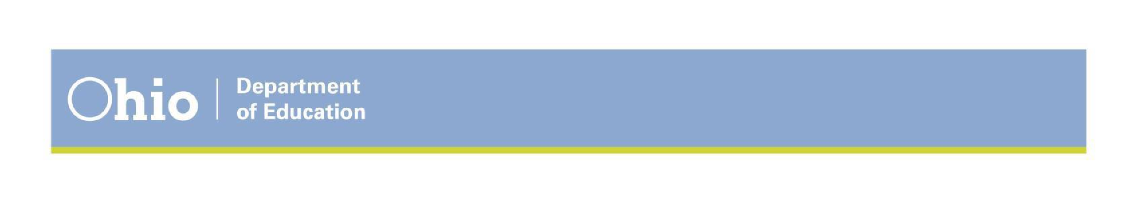

**House Bill 410 Requirements**

* Parent education and parenting programs;
* Mediation;
* Intervention programs available through juvenile authorities; and
* Referral for truancy, if applicable.

Updated district policies and procedures should reflect the following changes.

**DEFINITION OF TRUANCY AND EXCESSIVE ABSENCES**

1. ‘Chronic truant’ is removed from the law;
2. Definition of ‘habitual truant’ changed from days to hours. The new definition is:
   1. Absent 30 or more consecutive hours without a legitimate excuse;
   2. Absent 42 or more hours in one school month without a legitimate excuse; or
   3. Absent 72 or more hours in one school year without a legitimate excuse.
3. Includes ‘excessive absences’:
   1. Absent 38 or more hours in one school month with or without a legitimate excuse; or
   2. Absent 65 or more hours in one school year with or without a legitimate excuse.

**TRUANCY IS DECRIMINALIZED WITH SEVERAL CHANGES**

1. A district must remove ‘excessive truancy,’ from its zero tolerance policy for violent, disruptive or inappropriate behavior;
2. Students cannot be expelled or suspended (out of school) for being truant (beginning July 1, 2017); and
3. A district must take several steps to engage the student and his or her family before filing a complaint with juvenile court (including parental notification, an absence intervention team and an absence intervention plan detailed below). Juvenile court should consider alternatives to adjudication and adjudication should be used as a last resort. A complaint cannot be filed until:
   1. the 61st day after failed implementation of an absence intervention plan; or
   2. A child has been absent without a legitimate excuse for 30 or more consecutive hours or 42 or more hours in a school month during the implementation of an absence intervention plan.

**STUDENT DISCIPLINE CHANGES**

1. Schools may permit students to make up missed work due to out-of-school suspensions per district policy; and
2. Schools cannot apply any remaining part or all of a suspension to the following school year, but the superintendent may require a student to participate in community service or an alternative consequence for the number of hours equal to the time left on the suspension.

**EMIS REPORTING CHANGES**

1. When a district notifies a parent that a student has excessive absences;
2. When a child has been absent without a legitimate excuse for 30 or more consecutive hours, 42 or more hours in one school month, or 72 or more hours in one school year;
3. When a child, who has been adjudicated an unruly child for being a habitual truant, violates the court order regarding that adjudication; and
4. When an absence intervention plan has been implemented for a child who is habitually truant.

**DISTRICT RESPONSIBILITIES WHEN A CHILD HAS EXCESSIVE ABSENCES**

When a student is excessively absent from school, the following will occur:

1. The district will notify the student’s parents in writing within 7 days of the triggering absence;
2. The student will follow the district’s policy for addressing excessive absences; and 3. The district may refer the student and family to community resources as appropriate.

**DISTRICT RESPONSIBILITIES WHEN A CHILD IS HABITUALLY TRUANT**

When a student is habitually truant, the following will occur:

1. Within 7 school days of the triggering absence, the district will do the following:
   1. Select members of the absence intervention team;
   2. Make 3 meaningful attempts to secure the participation of the student’s parent or guardian on the absence intervention team.
2. Within 10 days of the triggering absence, the student will be assigned to the selected absence intervention team;
3. Within 14 school days after the assignment of the team, the district will develop the student’s absence intervention plan; and
4. If the student does not make progress on the plan within 61 days or continues to be excessively absent, the district will file a complaint in the juvenile court.

**Districts must establish an absence intervention team to be deployed only when a student is deemed habitually truant. Intervention teams for students excessively absent is at the discretion of the local district.**

The purpose of the absence intervention team is to establish a student-centered absence intervention plan for every child who is habitually truant by identifying specific barriers and solutions to attendance. The team is cross-sector and ideally includes the participation of the student and the parent. This requirement is new and is aimed at breaking down barriers to attendance without filing criminal complaints against the student in juvenile court.

1. Districts with a chronic absenteeism rate of 5 percent or greater must establish absence intervention teams for students who are habitually truant beginning with the 2017-2018 school year;
2. Schools are permitted to have their own absence intervention teams, but the district is responsible for developing a team if the school does not have one;
3. Membership of each team should vary based on the needs of each individual student, but each team MUST include:
   1. A representative from the individual’s school or district;
   2. Another representative from the school or district who has a relationship with the child;
   3. The child’s parent (or parent’s designee) or the child’s guardian, custodian, guardian ad litem or temporary custodian.
4. The district may invite a school psychologist, counselor, social worker, representative of a public or nonprofit agency or representative from the court to participate on the team.
5. The district must make three good faith efforts to engage the student’s parent or guardian. The parent may appoint a parent designee, such as a relative or other trusted adult, if the parent is unable to participate. If, after three good faith attempts, the district is unable to ensure participation of the parent, the team should develop the student’s absence intervention plan without the parent.
6. The district or school may consult or partner with public and nonprofit agencies to provide assistance, as appropriate, to students and their families to reduce absences.

Please send your questions and comments to schoolimprovement@education.ohio.gov to assist with the Department’s development of guidance and training materials.

**SUPPLEMENTAL RESOURCES FOR SCHOOL SOCIAL WORKERS**

Behavioral Health and Wellness Resources Toolkit <http://education.ohio.gov/getattachment/Topics/Student-Supports/Creating-Caring-Communities/Behavioral-Health-and-Wellness-Resources-Toolkit.pdf.aspx?lang=en-US>

Intervention Central

<https://www.interventioncentral.org/>

National Association of School Social Workers – School Social Work Practice Tools

<https://www.socialworkers.org/Practice/School-Social-Work/School-Social-Work-Tools/u19311q/5354414E4441524453>

Ohio Department of Education – PBIS

<http://education.ohio.gov/Topics/Student-Supports/PBIS-Resources>

Ohio Department of Education – Trauma Informed Schools <http://education.ohio.gov/Topics/Student-Supports/PBIS-Resources/Trauma-Informed-Schools>

Ohio School Social Work Association

<https://osswa.org/>

Ohio State Support Team for PBIS

<http://www.sst11.org/>

PBIS World

<https://www.pbisworld.com/>

Universal Design for Learning

<http://www.cast.org/whats-new/news/2016/udl-in-the-essa.html#.XWA59ui6PIU>

# Columbus city Schools

# COMPREHENSIVE SCHOOL SOCIAL WORK PLAN

# PRIMARY AUTHORS

**Name Title**

Marvella Allen, LISW-S Supervisor, Office of Social Emotional & Student Support Services

Joy Hotstetler, LSW District PBIS Coordinator/School Social Worker

# COMPREHENSIVE SCHOOL SOCIAL WORK PLAN CONTRIBUTORS:

**Name Title**

Brigette Lowery, LSW School Social Worker

Devorah Schlein, LSW School Social Worker

Kim Saunders, LSW School Social Worker

Kya Hatton, LSW School Social Worker

Victoria Waklatsi, LSW School Social Worker

Tyree Rivers, MSE District PBIS Climate & Culture Coordinator

1. ORC 3319.237
2. ORC 3319.237(B)
3. ORC 3319.46(B)(1)(c)
4. ORC 3302.03(C)(2)(h) 5 ORC 3313.534 6 ORC 3313.668(A)
5. ORC 3313.534(A).
6. ORC 3313.534(A); ORC 3313.668(B)
7. ORC 3313.66(B)(2)(a)
8. ORC 3313.66(B)(2)(b) 11 ORC 3313.66(B)(3)
9. ORC 3313.66(B)(3)
10. ORC 3313.66(B)(4) 14 ORC 3313.66(B)(5)
11. This definition is the same as contained in 34 CFR 300.530(h) (i) (3) and 18 USC 1365.
12. ORC 3313.66(A)(3)
13. ORC 3313.66(A)(1)
14. ORC 3313.66(C)(2)
15. ORC 3313.66(C)(2)(a)
16. ORC 3313.66(C)(2)(b)
17. ORC 3313.66(A)(2) 22 Section 9, HB 318
18. ORC 3313.668(B)(2) 24 ORC 3313.668(B)(2)
19. ORC 2305.51 December 2017